Today’s lesson is going to focus on greeting other when coming or leaving, and introductions using names and correct pronouns

1. **PRONOUNS**
   1. First going to go through pronouns using the chart below
      1. We have singular pronouns and plural pronouns, which I will be going through
      2. I, you, he, she, we, it, they – first say what the pronouns are and then use them in a sentence
         1. **I** am going to the market
            1. Singular pronoun
         2. **You** are going to school
            1. Singular pronoun
         3. I now pronounce **you** husband and wife
            1. Can be used in a plural setting
            2. Plural pronoun
         4. **He** is going to the store
            1. Singular pronoun
            2. Masculine
         5. **She** is going to the mall
            1. Singular pronoun
            2. Feminine
         6. **We** (you and i) are learning English
            1. Plural pronoun
         7. **It** is a green ball
            1. Singular pronoun
         8. **They** are going to the restaurant
            1. Plural pronoun
      3. **DO EXERCISE OF FILLING IN THE CORRECT PRONOUN BELOW (stopped before 11)**

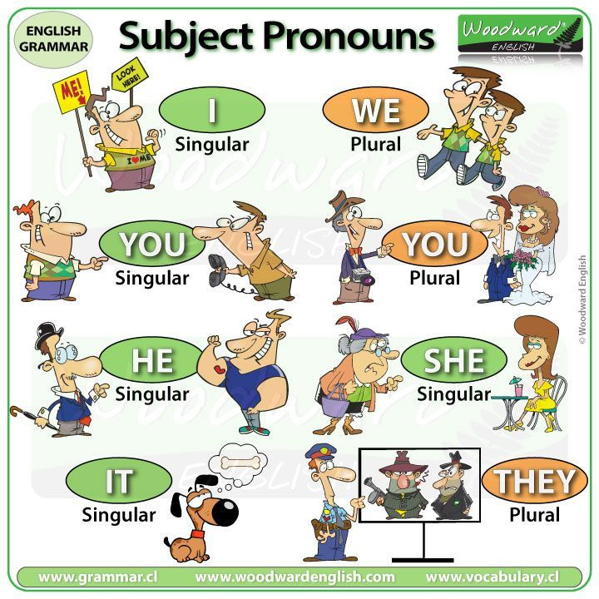

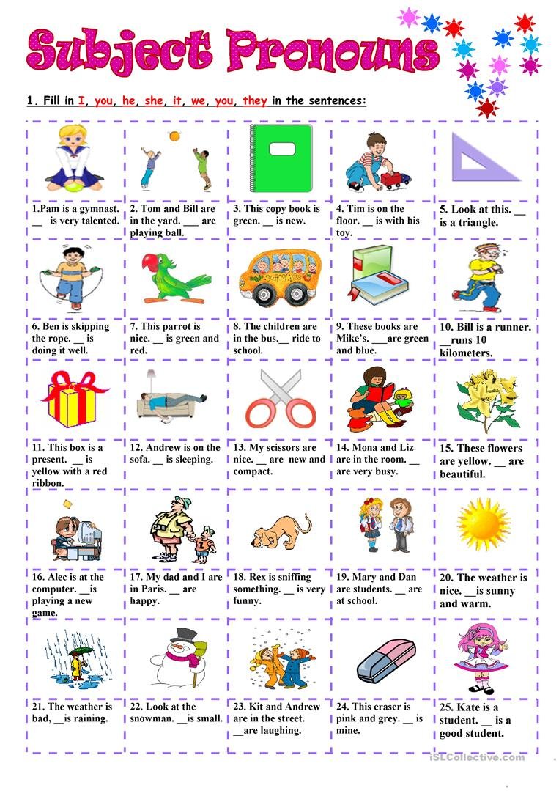

1. **GREETINGS AND LEAVE-TAKINGS**
   1. Important vocabulary for **greetings** and **leave-takings**
      1. Today
         1. Today is October 20th
      2. Tomorrow
         1. Tomorrow will be October 21st
      3. Yesterday
         1. Yesterday was October 19th
      4. Good
         1. I am good
      5. Well
         1. I am well
      6. Fine
         1. I am fine
      7. What
         1. What’s up?
      8. How
         1. How are you doing?
   2. **Greetings** – they are used when you meet someone
      1. Hi
      2. Hello
      3. Hey
      4. Good morning – if you are meeting someone in the morning time
      5. Good afternoon – if you are meeting someone in the afternoon time
      6. Good evening – if you are meeting someone in the nighttime
   3. **Leave-takings** – they are used when you are saying goodbye to someone
      1. Goodbye
      2. Bye
      3. See you later
      4. See you tomorrow
   4. Other **common questions/phrases** when talking to someone:
      1. If someone asks, “What is your name?”, you respond with:
         1. My name is Nikita, nice to meet you
      2. If someone asks, “How are you?” you can say:
         1. I am good
         2. I am fine
            1. You answer with this when you are not doing very well
            2. When you respond with this, the other person may ask “What’s wrong?”
      3. If someone asks, “How are you doing?”, you can respond with:
         1. I am doing well
         2. I am doing okay
         3. Not bad
            1. Used if you are feeling just okay
      4. “What’s up?” Is a more casual way of asking “how are you?”, you can respond with:
         1. Nothing much!
         2. Not much!
   5. **PRACTICE**
      1. If I ask you “what is your name?” what should your response be?
   6. **EXERCISE**
      1. https://www.english-at-home.com/lessons/speaking-exercise-greetings-introductions/